Tasks on S3

- Create an S3 bucket and upload some objects to S3.

Objective
To create an Amazon S3 bucket and upload files (objects) into the bucket for secure, scalable, and durable cloud storage

Purpose
- To understand how Amazon S3 stores data as objects.
- To learn how to create and manage S3 buckets.
- To upload and organize files in cloud storage.
- To make data available for backup, archiving, application hosting, and sharing.
- To gain hands-on experience with AWS storage services.

Steps:
  - Login to AWS console as root user
  - Navigate to S3 service.
  - Create a S3 bucket name, s3-bucket-07452 (Amazon S3 Buckets Create bucket)
  - Select bucket type as General Purpose, Bucket namespace as Global name space, object ownership as ACLS enabled disable Block all public access, Enable bucket versioning & create bucket.
  - Once created, I uploaded a object, linux-commands-cheat-sheet.png from my local machine.
  - Now to make that public access using the object url, go to object actions & select make public using ACL
  - Now I can access the uploaded object using the object url, https://s3-bucket-07452.s3.us-east-1.amazonaws.com/linux-commands-cheat-sheet.png

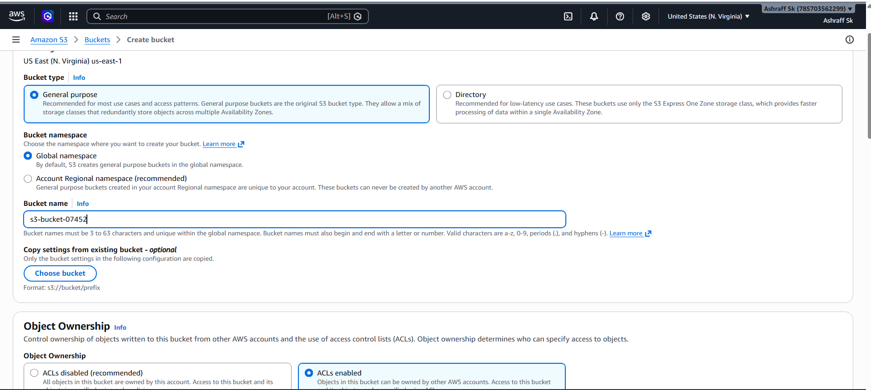

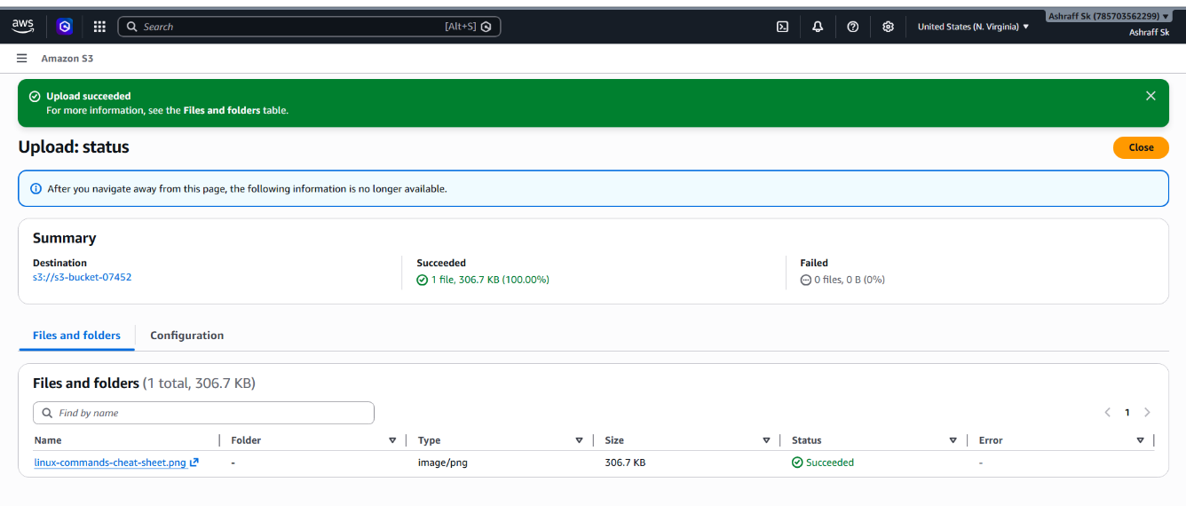
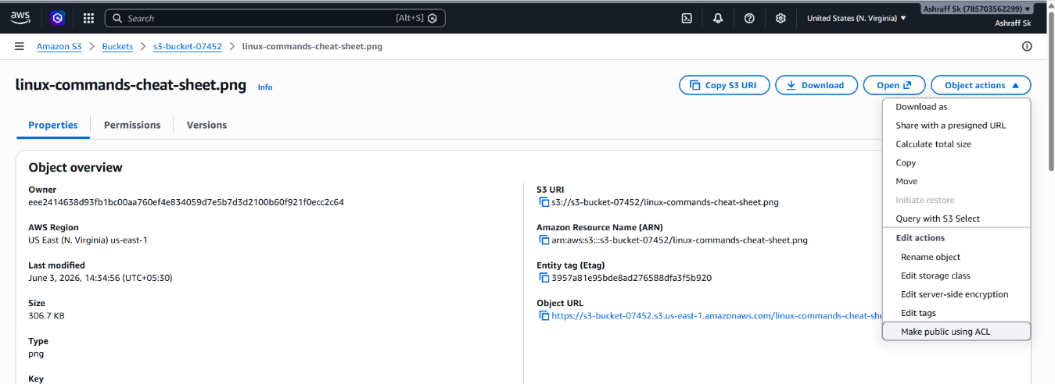

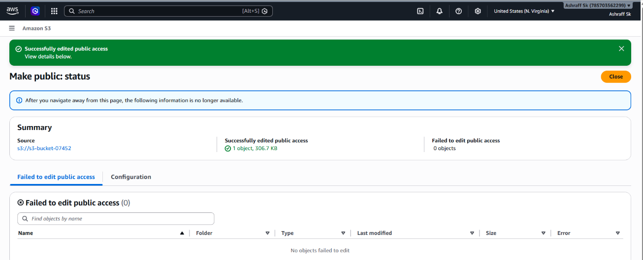

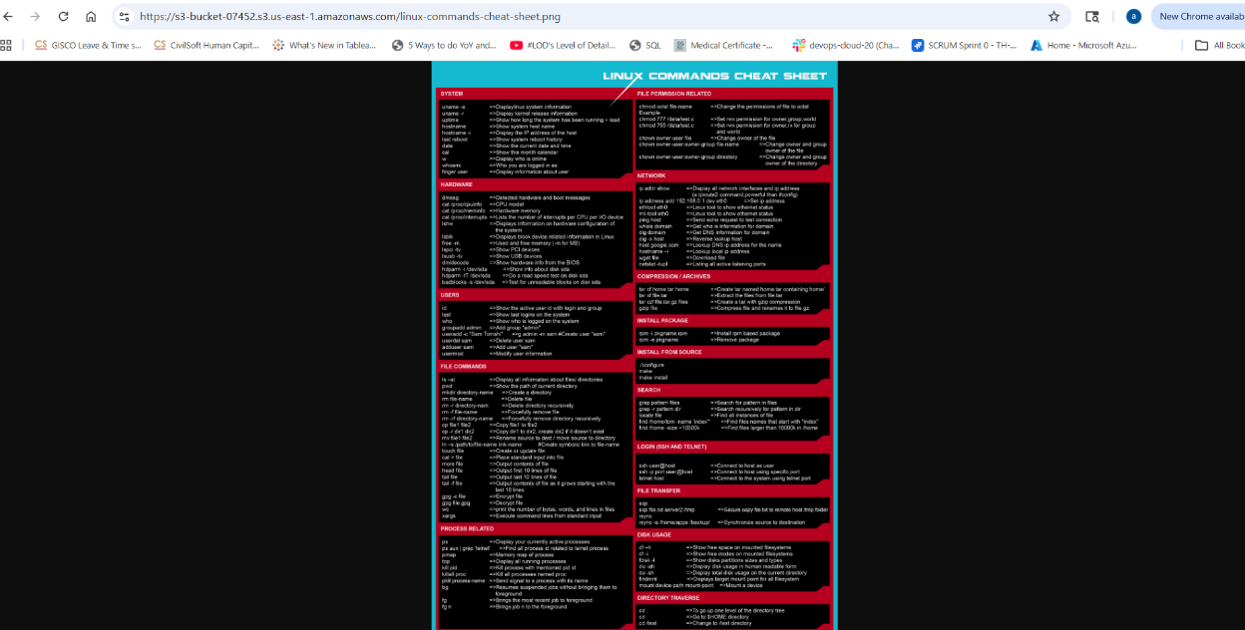

Conclusion:
After completing this task, we can:
- Create S3 buckets.
- Upload and manage objects in S3.
- Verify stored files using the AWS Console or AWS CLI.
- Understand the basic functionality of Amazon S3 and object storage in AWS

- Deploy a static website in the S3 bucket.

Objective
To host and deploy a static website using Amazon S3 by uploading website files (HTML, CSS, JavaScript, images) and enabling Static Website Hosting

Purpose:
- To understand static website hosting using AWS S3.
- To learn how to configure an S3 bucket for web hosting.
- To make website content accessible through a public URL.

Pre-requisite:
S3 bucket
Steps:
  - We created the s3-bucket-07452 in Task1.
  - Go To S3-bucket Properties & enable Static website hosting.
  - Created index.html & error.html files in our local machine & mention the given names in index document & error document of Edit static website hosting & save.
  - Next upload to s3-bucket-07452 & make as public by selecting make public using ACL under object actions
  - Now we can access the static website using the bucket website url, http://s3-bucket-07452.s3-website-us-east-1.amazonaws.com from s3-bucket properties section
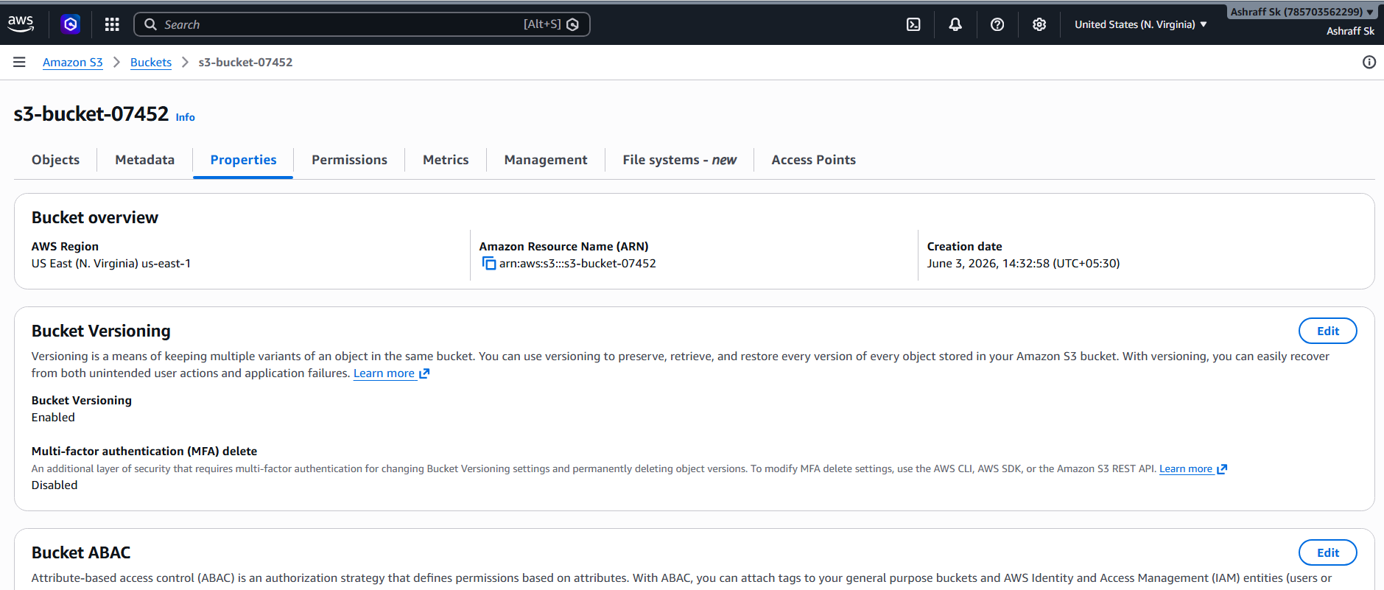
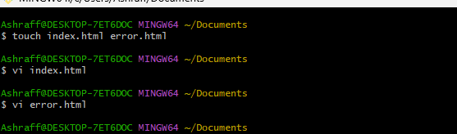
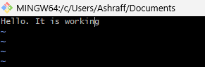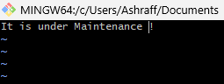

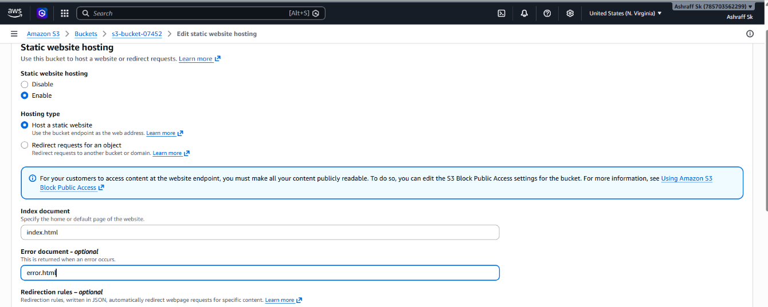
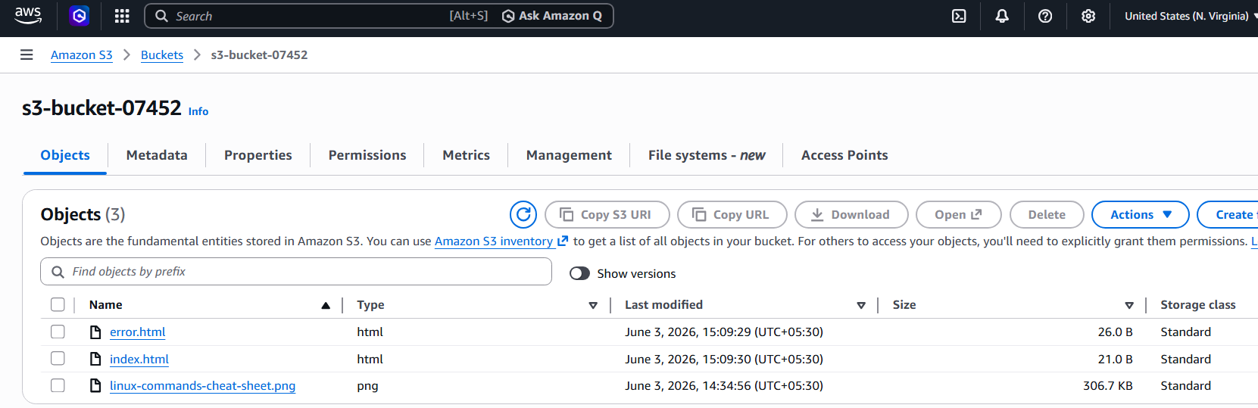
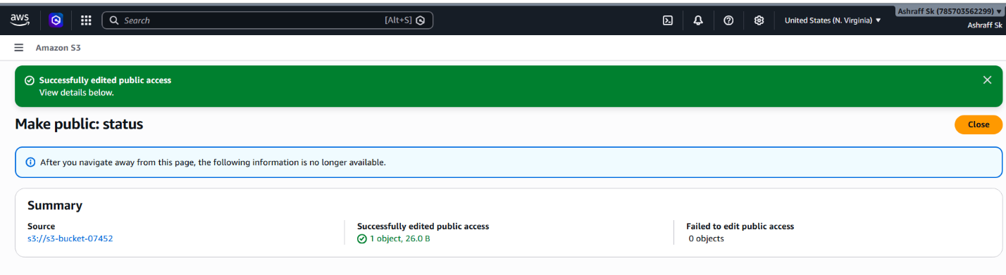

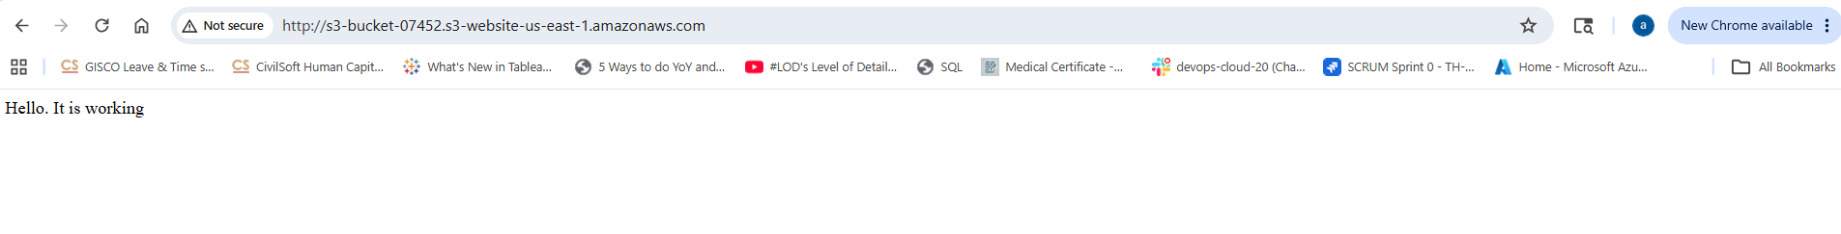
Advantages:
- Low-cost website hosting
- Highly available and durable storage
- No web server management required
- Easy deployment and maintenance
- Suitable for portfolios, landing pages, documentation sites, and static web applications

- Enable cross-region replication on S3 buckets.

Objective
To configure Cross-Region Replication (CRR) between two Amazon S3 buckets located in different AWS Regions, ensuring automatic replication of objects for disaster recovery, high availability, and compliance requirements.

Purpose
- To automatically replicate S3 objects from one region to another.
- To improve data durability and business continuity.
- To support disaster recovery strategies.
- To reduce latency by keeping copies of data closer to users.
- To meet compliance and backup requirements.

Prerequisites
Before enabling CRR:
Source bucket exists
Destination bucket exists
Versioning enabled on both buckets
IAM role for replication
Steps:
- We have s3-bucket-07452 in N.virgina region
- Similarly create a s3-bucket-05868 in Ohio region enabling the bucket versioning, ACLS enabled & disable block all public access
- Now go to N. virginia s3 bucket, s3-bucket-07452 & go to Management section, Replication rules, create replication rule
- Enter rule name as new replication rule, status as Enabled
- Choose a rule scope as Apply to all objects in the bucket
- Destination as choose a bucket in this account
- IAM role as create a new role & click save
- Now in I’ll upload one file, agile.png in s3-bucket-07452 of N.virginia region and make public access
- The same file is replicated in s3-bucket-05868 of ohio region.

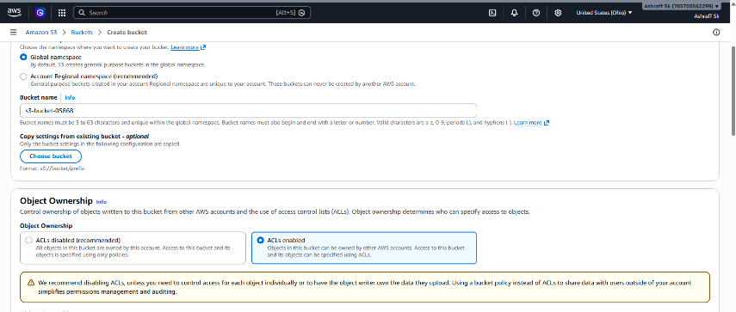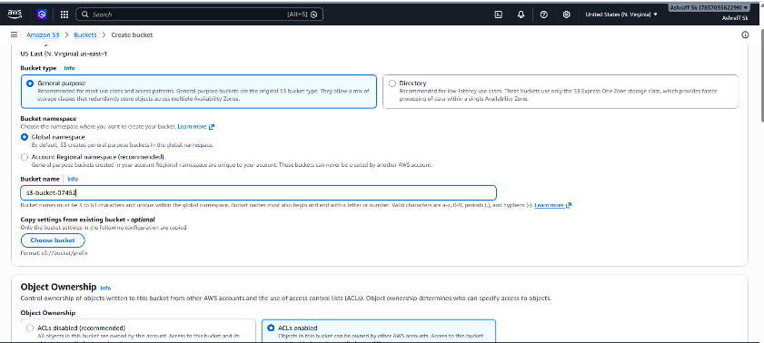
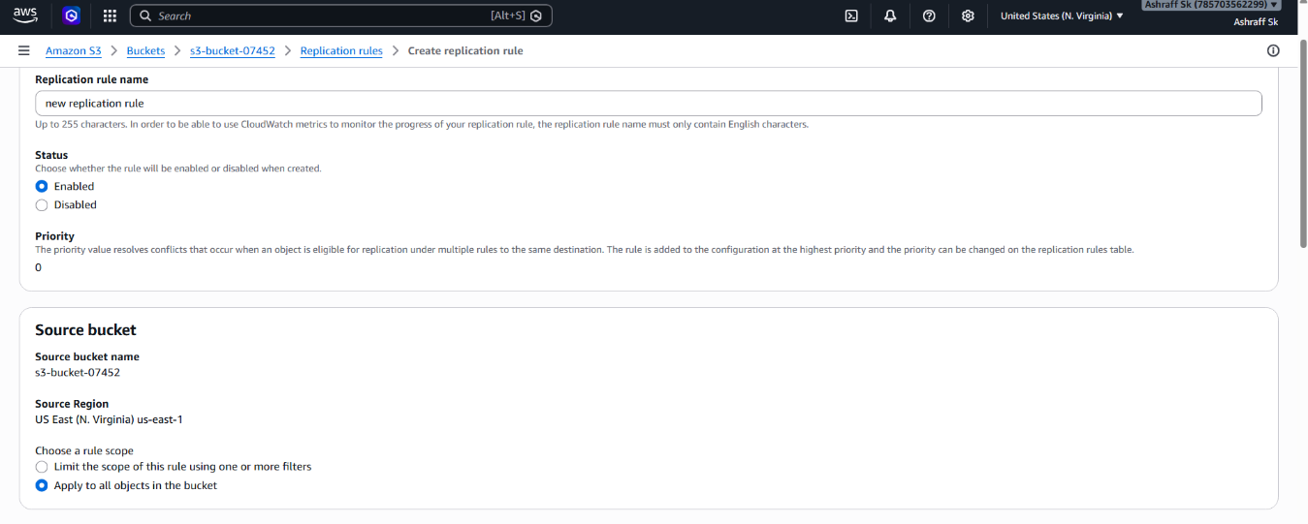
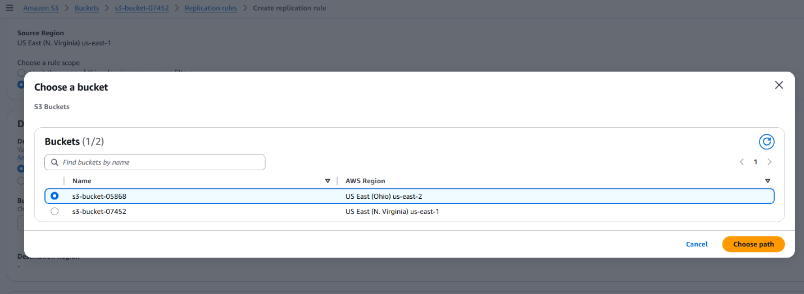
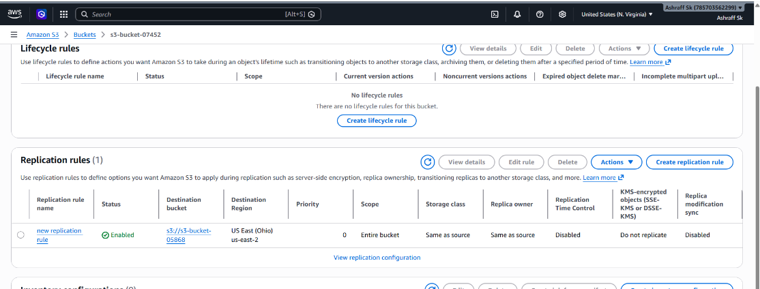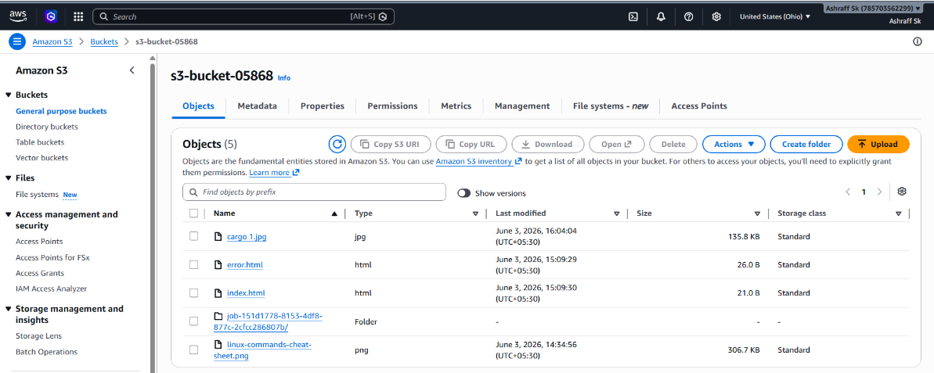
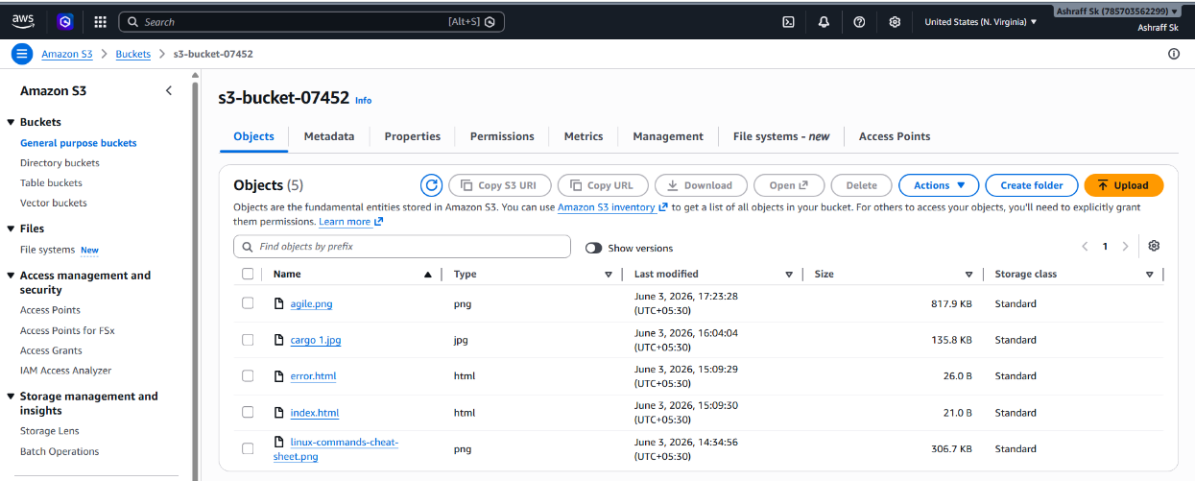
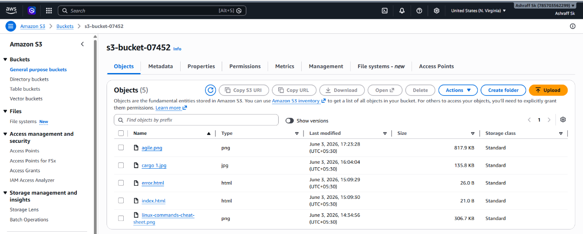

Conclusion:
High Availability
Copies exist in multiple AWS Regions.
Compliance
Helps satisfy data retention and backup requirements.

- Configure a bucket policy so only the Admin user can see the objects of the S3 bucket.

Objective
To configure an Amazon S3 bucket policy that allows only a specific IAM Admin user to view and access objects stored in the S3 bucket while denying access to all other users.

Purpose
- To implement secure access control for S3 buckets.
- To restrict object visibility to authorized users only.
- To protect sensitive data from unauthorized access.
- To understand S3 Bucket Policies and IAM-based access control.

Steps:

      - Go to IAM IAM Users Create userAdmin-user & click Next
      - In Set Permissions Attach policies directly
      - Select AdministratorAccess policy & click Next & create user
      - Go to the S3 Console → select your bucket.
      - Navigate to Permissions → Bucket Policy → Edit.
      - Paste the JSON above (with your values).
      - Save changes.
      - Now login with IAM user, Admin-user and check the access

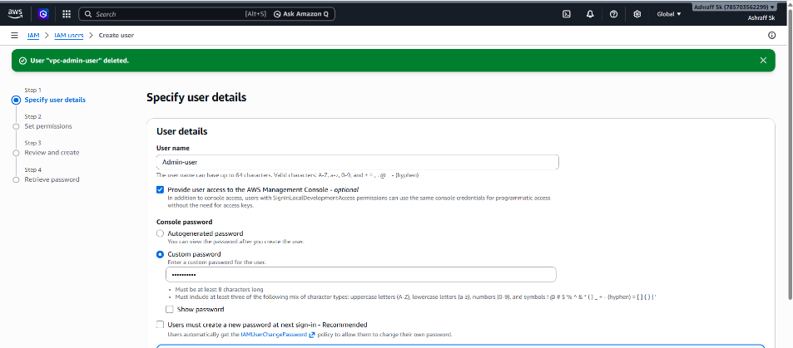
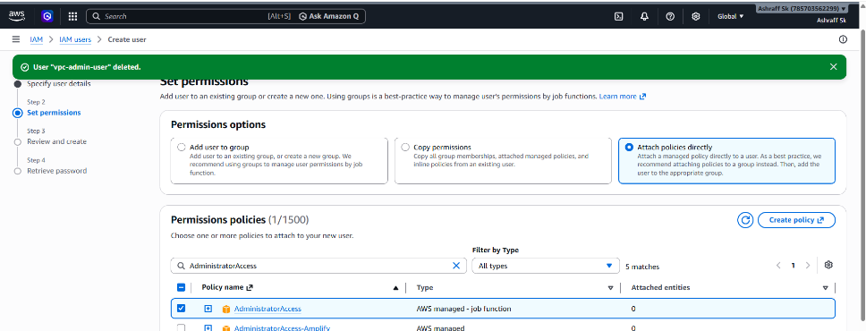
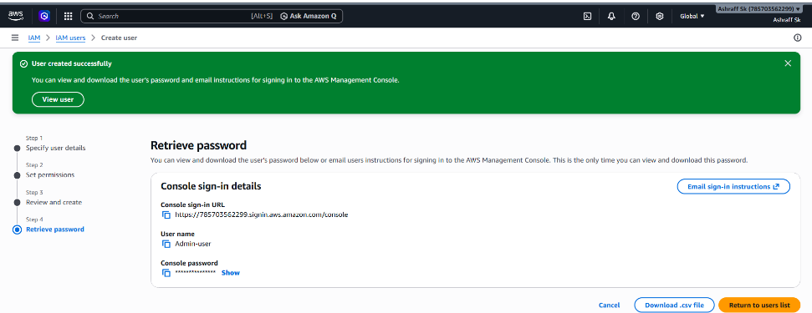
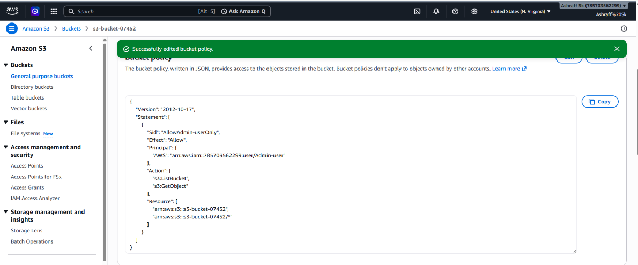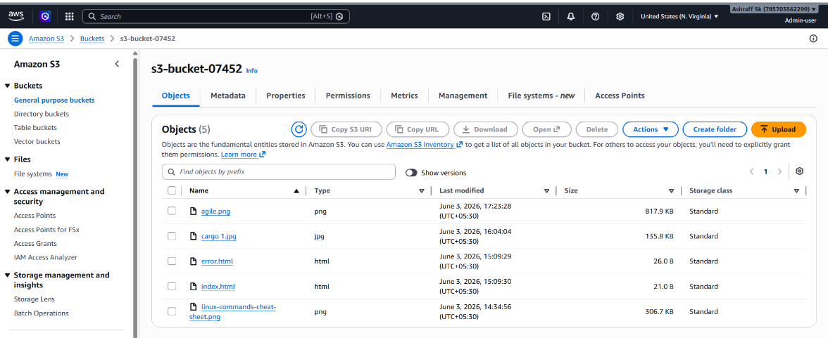

Conclusion:

The S3 bucket policy was successfully configured so that only the specified Admin IAM user could view and access objects stored in the bucket. Unauthorized users were denied access, ensuring secure storage of sensitive data and demonstrating effective implementation of AWS access control using S3 Bucket Policies and IAM identities.

- Set up lifecycle policies to automatically transition or delete objects based on specific criteria.

Objective
To configure an Amazon S3 Lifecycle Policy that automatically transitions objects to lower-cost storage classes or deletes them after a specified period, reducing storage costs and simplifying data management.

Purpose:
- To automate S3 object management.
- To reduce storage costs by moving infrequently accessed data to cheaper storage classes.
- To automatically delete old or unnecessary files.

Pre-requisite:
S3-bucket with objects.

Steps:
      - We have created a s3-bucket-07452 & uploaded some objects
      - Go to s3-bucket-07452 Management & select create lifecycle rule
      - Name as Lifecycle rule name Archieve-and-delete-objects
    - Choose a rule scope Apply to all objects in the bucket & acknowledge
    - In Lifecycle rule actions select Transition current versions of objects between storage classes & acknowledge.
    - Choose storage class transitions Days after object creation
      - Standard-IA 30
      - Glacier Instant Retrieval 90
    - Then create rule
    - In Lifecycle rules we can see the Archieve-and-delete-objects status as Enabled

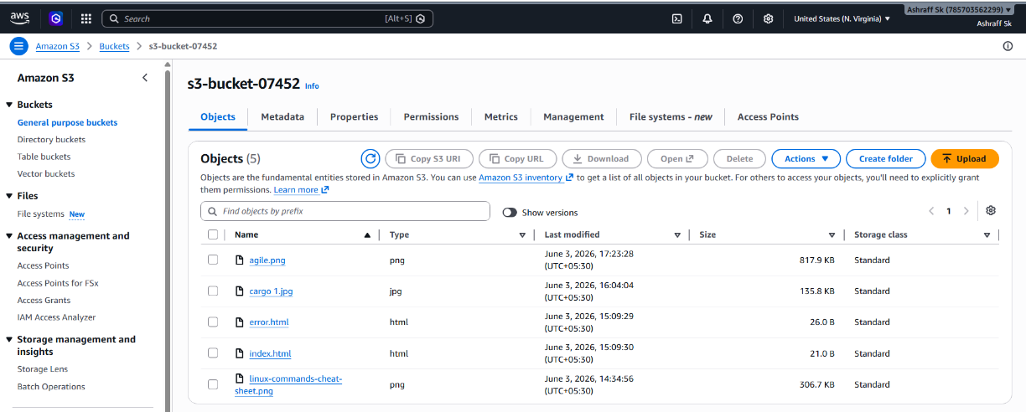
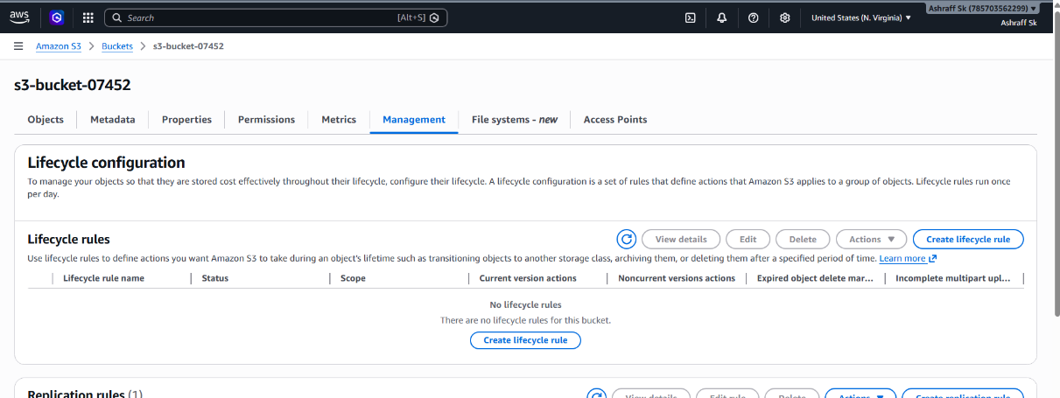
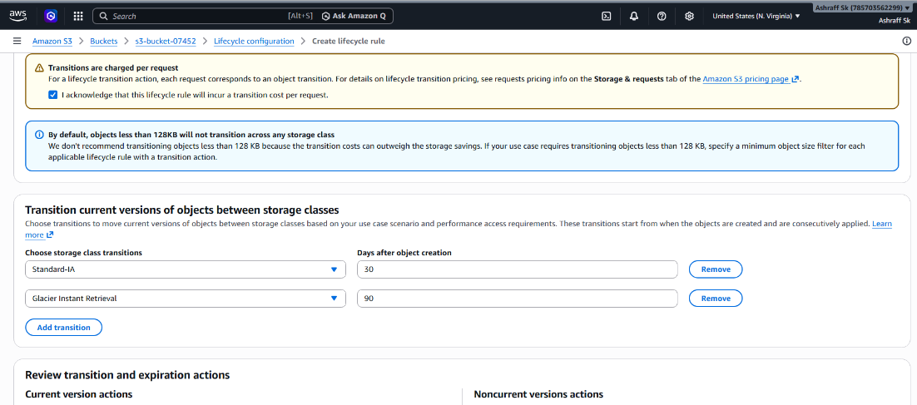

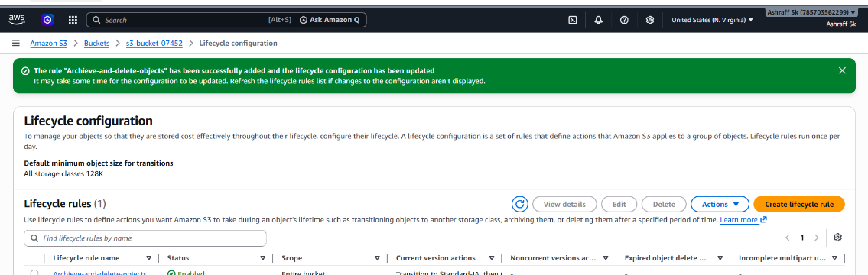
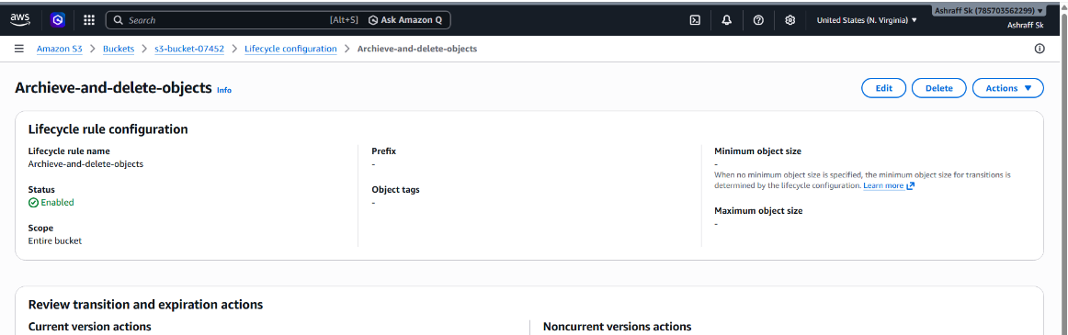

Use Cases
- Log Archiving
- Backup Retention
- Temporary Files
- Compliance Records

- Push some objects to S3 using the AWS CLI.

Objective:
To upload files (objects) from a local machine or EC2 instance to an Amazon S3 bucket using the AWS Command Line Interface (AWS CLI).

Purpose:
- To learn how to interact with Amazon S3 using AWS CLI.
- To upload files and folders to S3 programmatically.
- To automate file transfers and backups.
Steps:
- Created a s3-bucket-07452
- Now go to git bash & run aws –version
- Next run aws configure
- Enter the AWS access key ID, AWS secret access key of root user, region name us-east-1 & output format json.
- Now I will create two files, file1.txt & file2.txt
- First I will upload file1.txt using the command aws s3 cp file1.txt s3://s3-bucket-07452/
- Now I will run the command aws s3 ls s3://s3-bucket-07452 to list the uploaded and available objects & file1.txt is uploaded
- I will upload file1.txt using the command aws s3 cp file2.txt s3://s3-bucket-07452/
- Now I will run the command aws s3 ls s3://s3-bucket-07452 to list the uploaded and available objects & file2.txt is uploaded

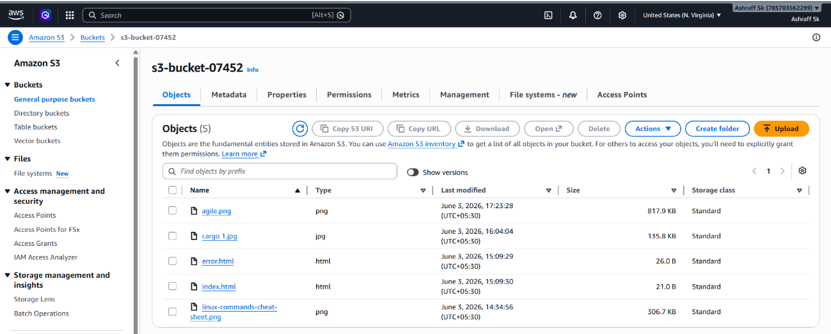
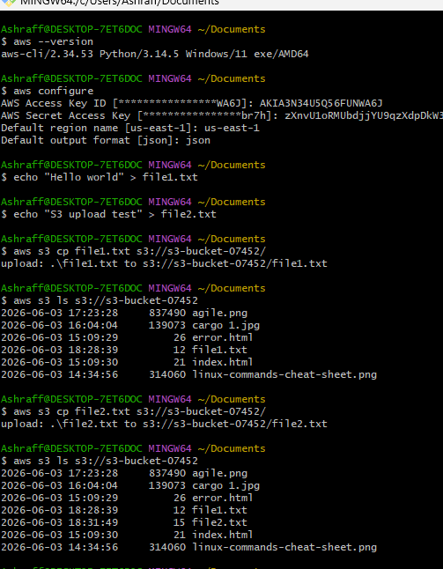
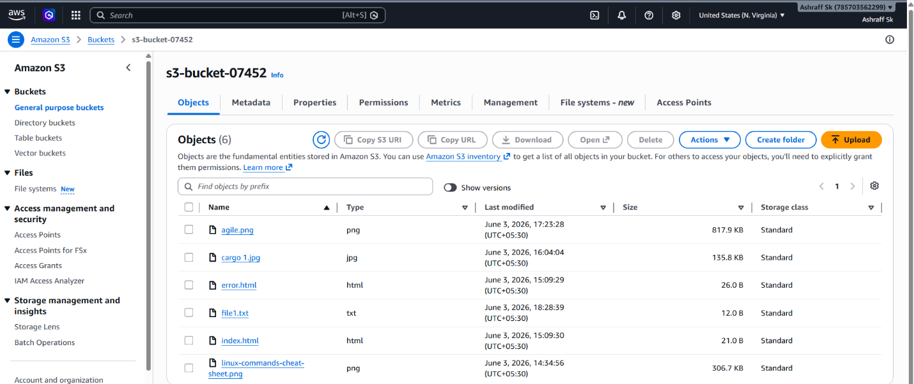
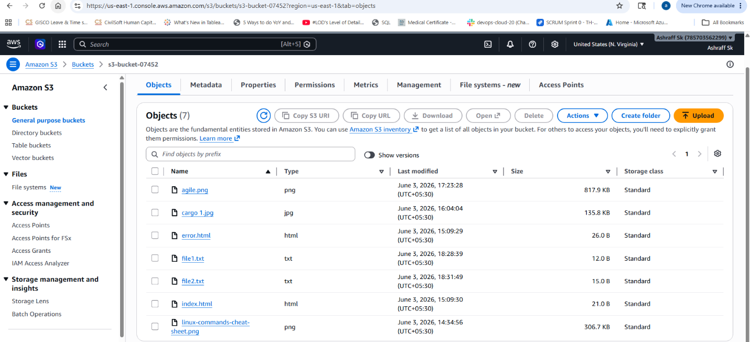

Conclusion
Objects were successfully uploaded to Amazon S3 using AWS CLI commands. The AWS CLI provides a fast and efficient way to manage S3 storage, automate file uploads, perform backups, and integrate S3 operations into scripts and automation workflows.

- Write a Bash script to create an S3 bucket.

Objective:
To create an Amazon S3 bucket automatically using a Bash script and AWS CLI, reducing manual effort.

Purpose:
- To automate S3 bucket creation.
- To learn AWS CLI integration with shell scripting.
- To eliminate repetitive manual tasks.

Steps:

#!/bin/bash
# Variables
BUCKET_NAME="s3-bucket-05869-$(date +%s)"
REGION="us-east-1"
# Create S3 Bucket
if [ "$REGION" == "us-east-1" ]; then
aws s3api create-bucket \
--bucket "$BUCKET_NAME"
else
aws s3api create-bucket \
--bucket "$BUCKET_NAME" \
--region "$REGION" \
--create-bucket-configuration LocationConstraint="$REGION"
fi
# Verify
if [ $? -eq 0 ]; then
echo "S3 bucket created successfully: $BUCKET_NAME"
else
echo "Failed to create S3 bucket"
fi

- Save the script as create_s3_bucket.bash.
- Make it executable:
- bash
- chmod 600 create_s3_bucket.bash
- Run bash create_s3_bucket.bash
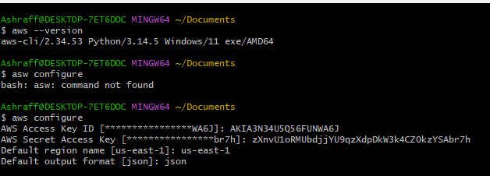
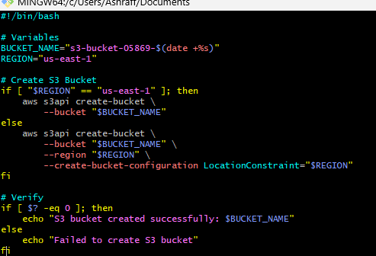
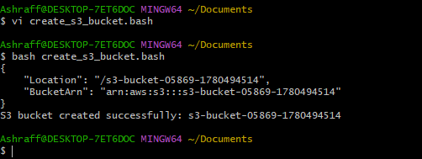
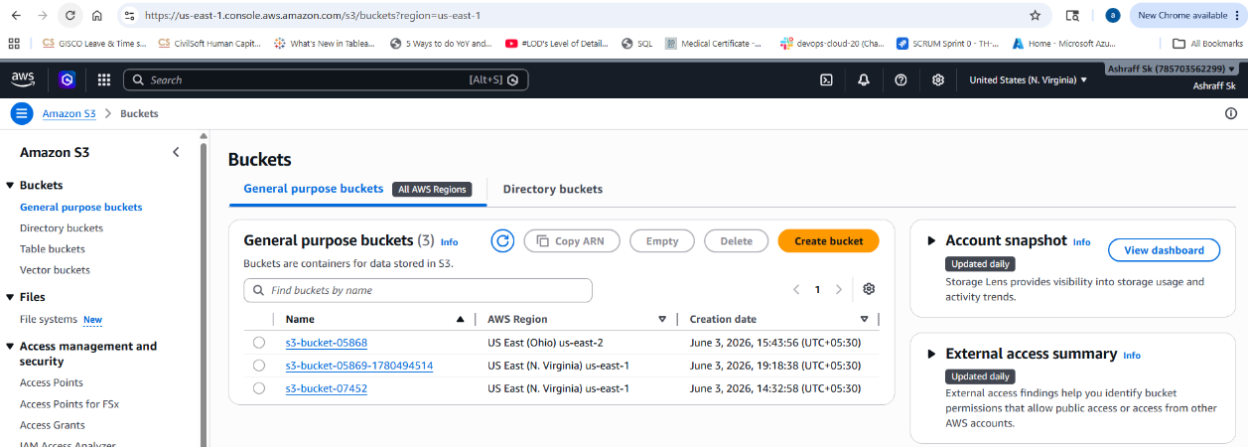

Use Case:
Automated Environment Setup
Instead of creating buckets manually through the AWS Console, a Bash script can create them automatically

- Upload a 1 GB file to S3 using the CLI.

Objective:
To create and upload a 1 GB file to an Amazon S3 bucket using the AWS CLI and verify the upload.

Purpose:
- To learn how to upload large files to Amazon S3.
- To understand S3 object storage and AWS CLI operations.
- To test S3 upload performance and connectivity.

Steps:
  - We have a created s3 bucket, s3-bucket-05868
  - To upload 1 GB file go to Git bash run the command aws s3 cp D:/Downloads/1GB.bin s3://s3-bucket-05868
  - To verify the upload run command aws s3 ls s3://s3-bucket-05868

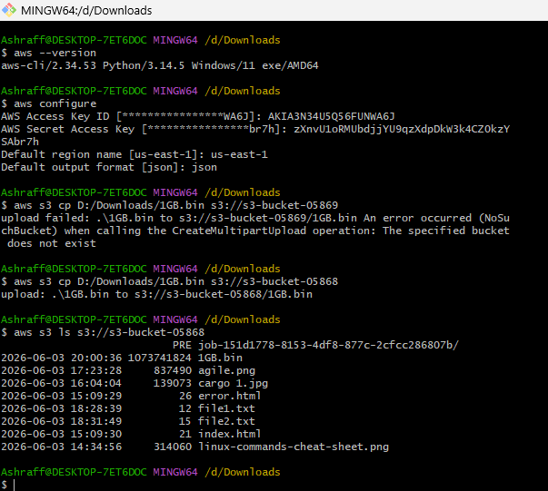
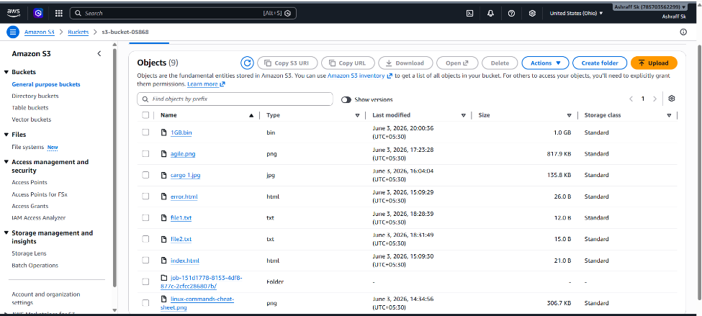
Use Case
- Organizations often upload:
  - Application backups
  - Database dumps
  - Log archives
  - Media files

